  CONTACTING YOUR LOCAL REPRESENTATIVE FROM THE MANITOBA HARM REDUCTION NETWORK
  Mikayla Johnson (she/her)
  Network coordinator, northwest Interlake (Ashern/Eriksdale)
  Office located at 35 Railway Avenue, Eriksdale, MB.
  Email: mikayla@mhrn.ca
  Office phone: (204) 739-4459 ext. 2233
  www.mhrn.ca
  ASHERN
  Ashley Bobier RN, BN
  Public Health Nurse
  Interlake-Eastern Regional Health Authoritywww.ierha.ca
  Ashern Community Health Office
  Box 310
  1 Steenson Drive
  Ashern, MB R0C 0E0
  Desk: (204) 768-2585 ext. 227
  Cell: (204) 302-1195
  Fax: (204) 768-3879
  Email: abobier@ierha.ca
  LUNDAR AND ERIKSDALE
  Chantal Einarson RN BN
  Public Health Nurse
  Interlake Eastern Regional Health Authority www.ierha.ca
  Lundar Health Center
  97 First Street South, PO Box 296
  Lundar, MB R0C 1Y0
  Phone: 204-762-6505 VOIP 27107
  Cell Phone: 204-280-0227
  Fax: 204-762-5164
  Lundar- Monday, Wednesday, Friday
  Eriksdale Wellness Center
  35 Railway Avenue, PO Box 503
  Eriksdale, MB R0C 0W0
  Phone: 204-739-4455
  Cell Phone: 204-280-0227
  Fax: 204-739-5544
  Email: ceinarson@ierha.ca
  Eriksdale – Tuesday, Thursday
  WHERE TO FIND YOUR LOCAL PUBLIC HEALTH NURSE
  IMMEDIATE ASSISTANCE FOR STUDENTS
  Kids Help Phone: 1-800-668-6868
  Canada Suicide Prevention Service: 1-833-456-4566
  Manitoba Suicide Prevention & Support Line: 1-877-435-7170
  Drug and Alcohol Helpline: 1-800-565-8503
  Crisis Call Centre: 800-273-8255
  Alcohol Anonymous Teen Hotline: 888-425-2666
  National Alcohol and Substance Abuse Information Center: 800-784-6776
  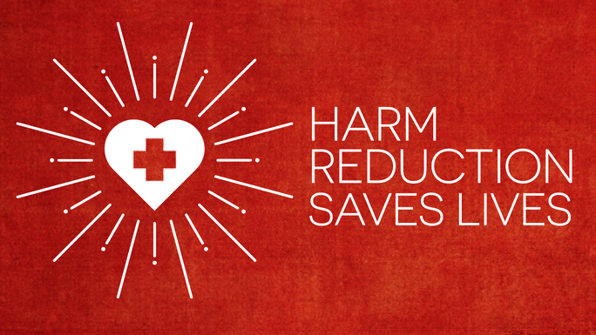
  GUIDE FOR TEACHERS:
  INTRODUCING HARM REDUCTION IN YOUR CLASS ROOM
  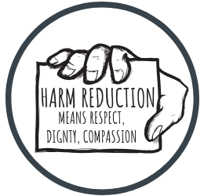
  Written by Julie Hochman, René Piché, and Carly Meyer in partnership with the Manitoba Harm Reduction Network
    - [Subtitle]

INTRODUCTION
This guide will assist you in finding methods to appropriately introduce harm reduction in your class room. This guide was made by students from the University of Saint-Boniface in partnership with the Manitoba Harm Reduction Network (MHRN) in efforts to provide education to teachers in order to have more tools and resources regarding harm reduction for their students in the classroom.

TIPS ON HOW TO INTRODUCE HARM REDUCTION IN YOUR CLASSROOM
- Provide a safe, non-judgemental environment for your students.
- Show visually appealing educational videos from YouTube to capture your student’s attention
- Create a harm reduction question box. Have an anonymous box available in your classroom where students can put questions in it that they may not feel comfortable asking in person. Find answers online, or through contacting your local public health nurse and share the answers with the class so that everyone can learn.
- Put posters up in your classroom regarding safe sex and drug use. The more they receive education, and the more these topics are talking about, the higher the chances of a student in need reaches out for help. There are many free posters available on the MHRN website. https://mhrn.ca/community-projects
- Help end the stigma. Don’t be shy to bring up the importance of safe sex and drug use around teens. Harm reduction accepts these practices as a reality in our society. Realizing that your students are possibly engaging in harmful acts, and speaking openly about harm reduction can help your students realize that there are safer ways to have sex and do drugs.
- Take the time to talk about it in your classroom on a regular basis (ideally, talk about it weekly.) This will remind your students on a regular basis that they are not alone, and that they can come to their teachers to receive the guidance that they need.

“Harm reduction is a practical set of strategies and tools to help people stay safer when engaging in activities that could have risk, like sex and drug use” – MHRN

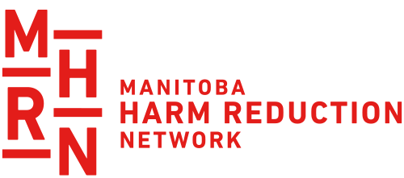

FEATURES OF A HARM REDUCTION APPROACH FROM THE MHRN WEBSITE
- Accepts that sex and drug use are part of our world and works to minimize potential harmful effects
- Understands drug use as a complex phenomenon that encompasses a continuum of behaviors and acknowledges that some activities and ways of using are safer than others
- Calls for non-judgmental, non-coercive services and resources to support people who use drugs and their communities in reducing harm
- Ensures that people who use drugs are meaningfully involved in the creation of programs and policies designed to serve them
- Recognizes that the realities of colonization, poverty, class, racism, social isolation, past trauma, homophobia, and other social inequalities affect people’s ability to access services and mitigate harms
For more information, visit www.mhrn.ca

EDUCATIONAL VIDEOS FOR THE CLASSROOM
What is Harm Reduction? (a real-life glimpse into harm reduction work by health care professionals) https://www.youtube.com/watch?v=ikmKxgCTXFA
What is Harm Reduction? (Cartoon) https://www.youtube.com/watch?v=lM0sCVf9_tA
What is Harm Reduction? (Illustration) https://www.youtube.com/watch?v=FtFYMEOetAs
Harm reduction for opioids: A Canadian perspective https://www.youtube.com/watch?v=glOT8_dQjTQ
Harm Reduction 101 https://www.youtube.com/watch?v=W7epsLmN604

WEBSITES FOR INFORMATION AND RESOURCES
Manitoba Harm Reduction Network www.mhrn.ca
Addictions Foundation of Manitoba https://afm.mb.ca
National Harm Reduction Coalition https://harmreduction.org/
TowardTheHeart.com – Harm Reduction Services https://towardtheheart.com/

